Install Python environment on your Windows
1. Click Downloads > Python 3.x.x
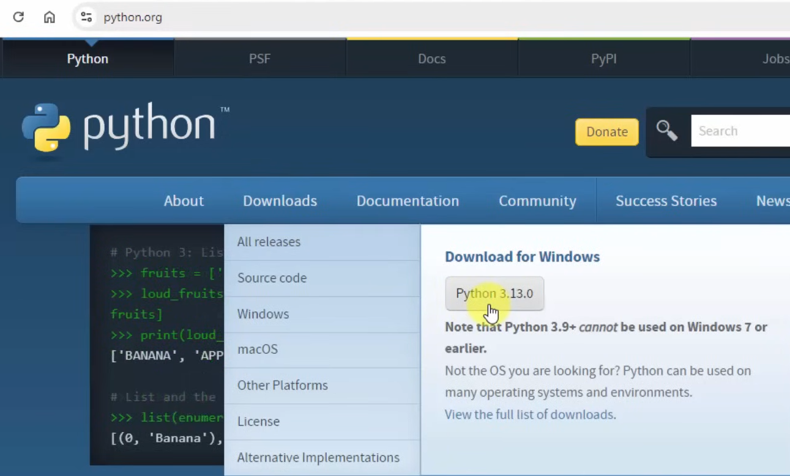

2. Check:
- Use admin privileges when installing py.exe
- Add python.exe to PATH
> Customize installation
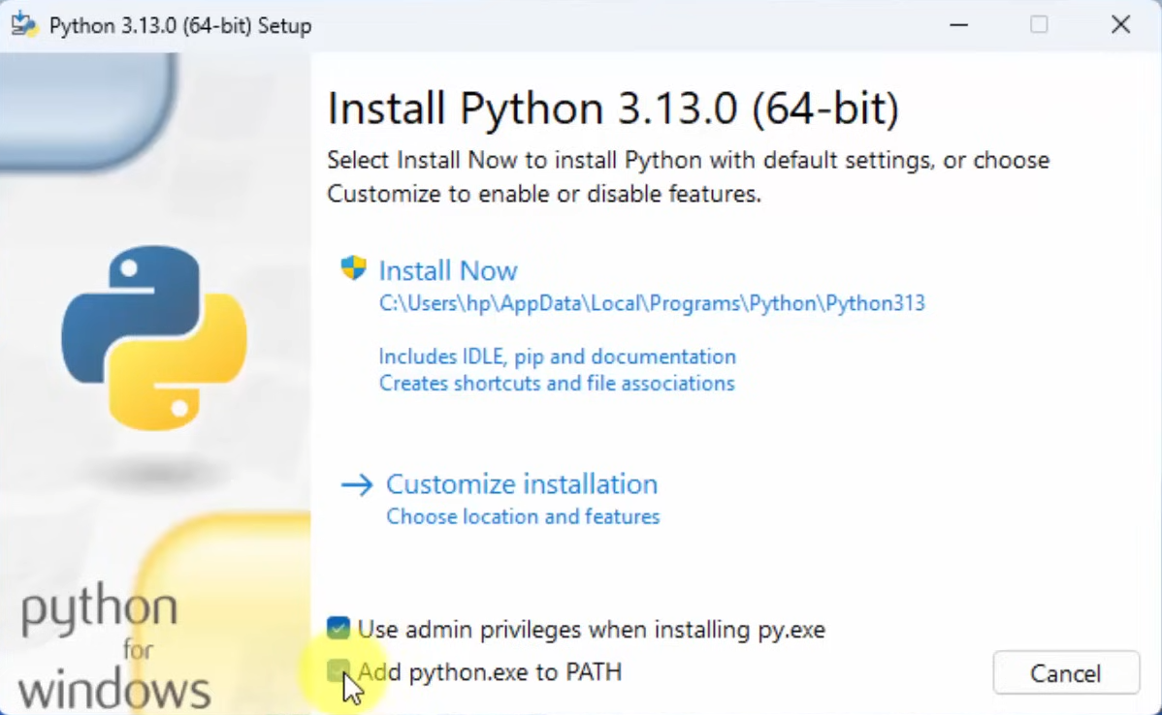

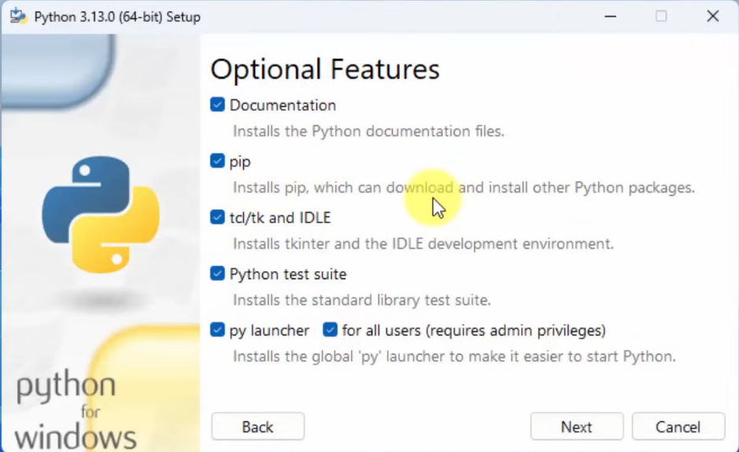
3. Check all > Next

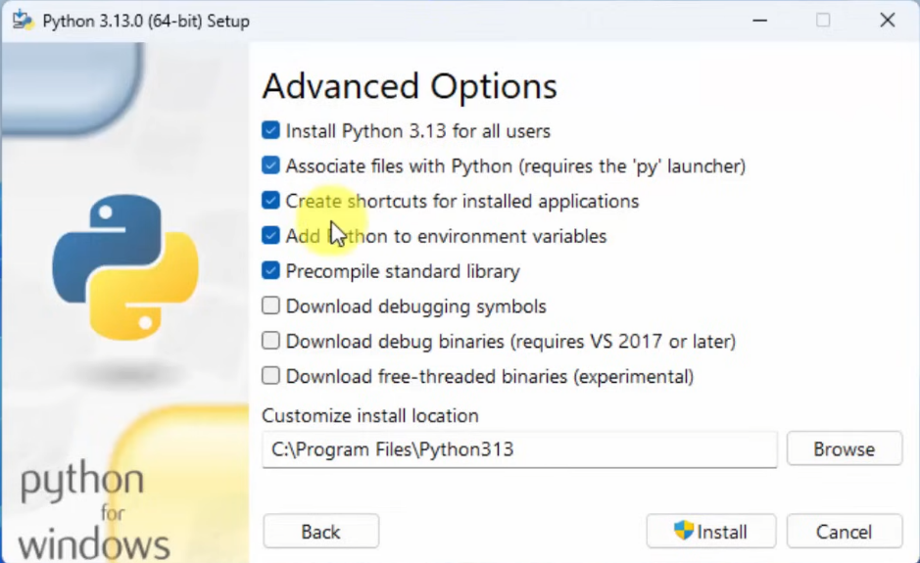
4. Advanced options
Check:
- Install Python 3.13 for all users
- Associate files with Python
- Create shortcuts for installed applications
- Add Python to environment variables
- Precompile standard library
> Install

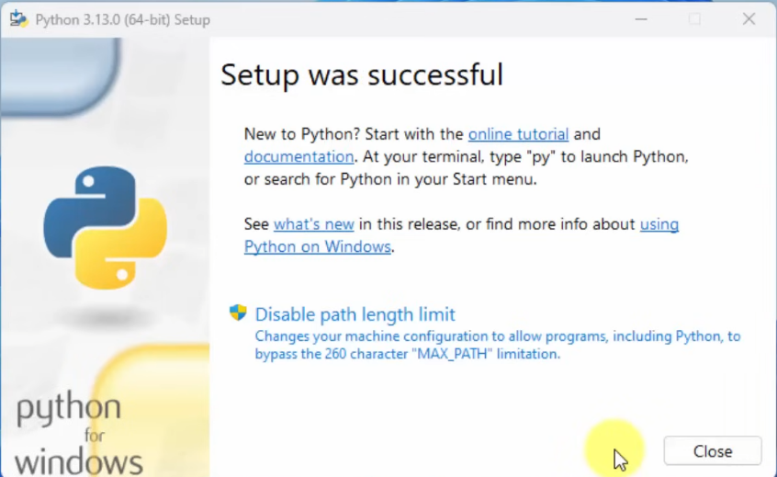
5. Complete installation: click Close

ODBC SQL Server Connection
- Install ODBC Driver17
Url: https://learn.microsoft.com/en-us/sql/connect/odbc/download-odbc-driver-for-sql-server?view=sql-server-ver17
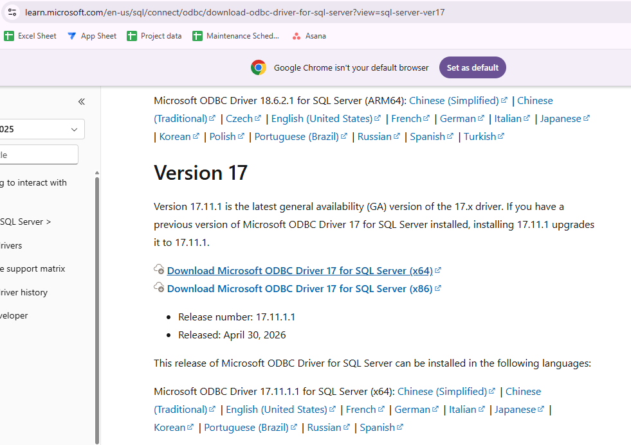

Click next
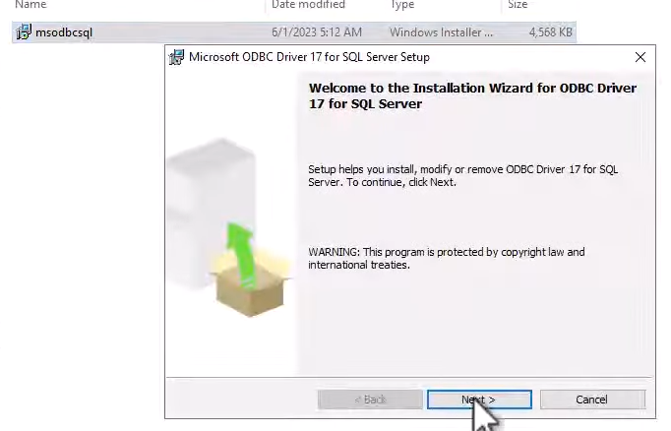
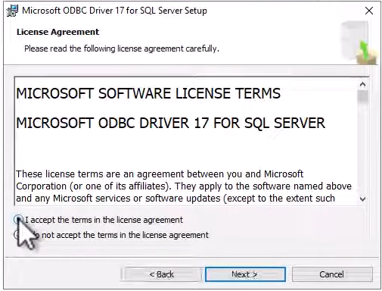
Check: I accept the term in the license agreement > Next

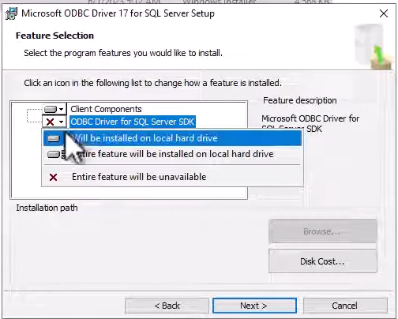
Click ODBC Driver for SQL Server SDK > Will be installed on local hard drive > Next

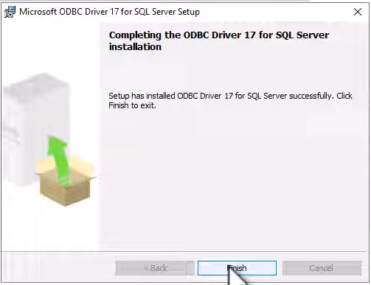
Next > Finish

Configure ODBC
- Search ODBC Data Sources (64-bit)
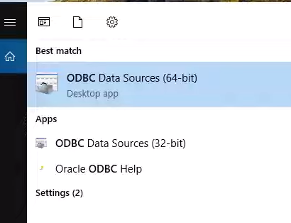

Click System DSN > Add
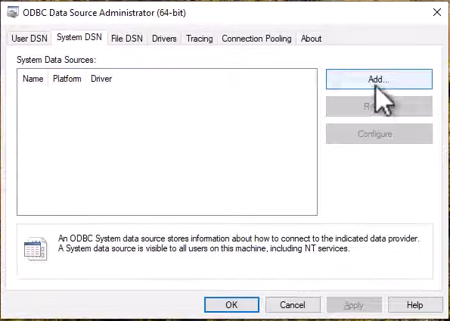
Choose ODBC Driver 17 for SQL Server
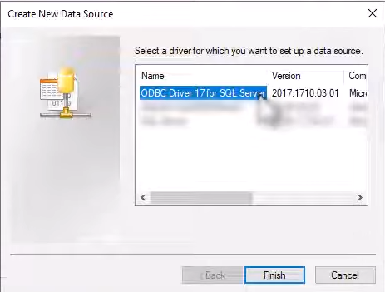
Fill in the details accordingly
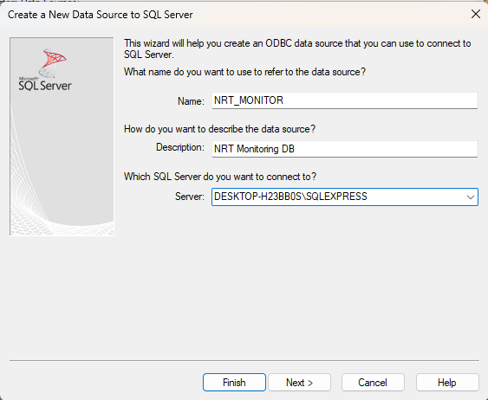
Name: NRT_MONITOR
Description: NRT Monitoring DB
Server: <Choose your ssms server name>
> Next

If your server is authenticated checked: “With SQL Server authentication using a login ID and password entered by the user”
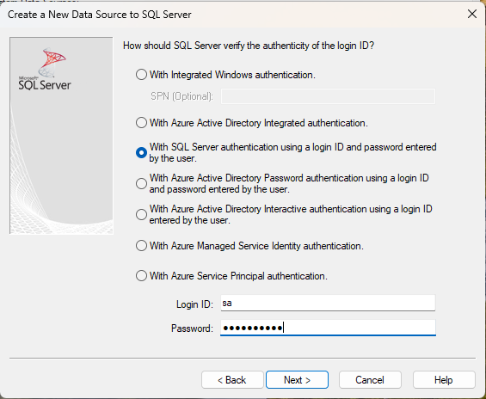
Enter your login ID and password > Next
Login ID: sa
Password: qwerty7890
If your server is unauthenticated, choose “With Integrated Windows authentication” > Next
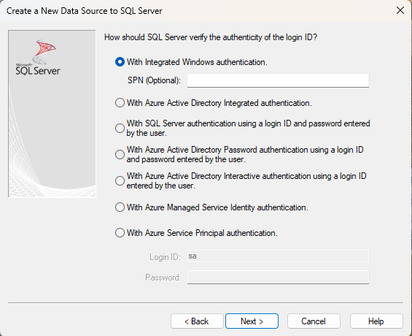
Change the default database to: ParkingServerDB > Next
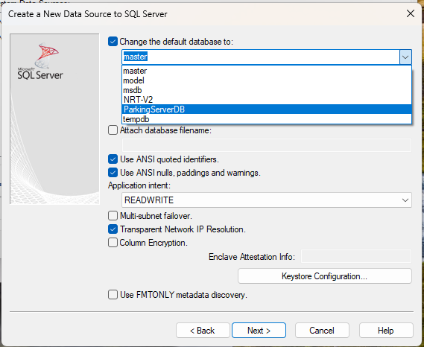
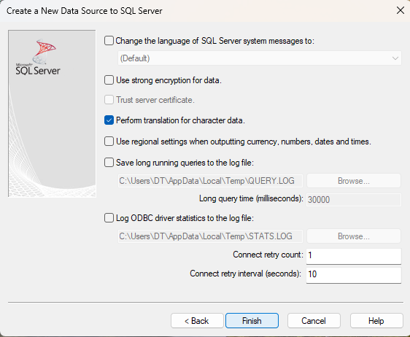
Click Finish

Click Test Data Source
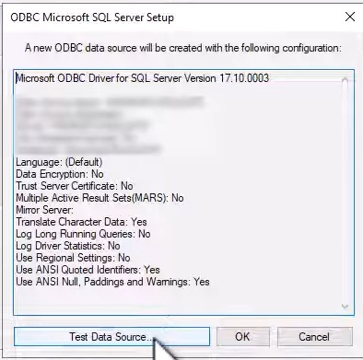
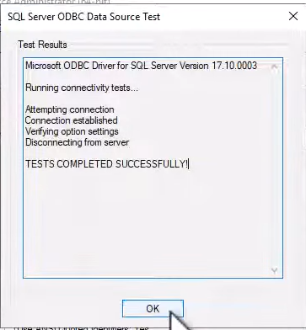
If you see ‘Connection established’, it means the connection is successful > click OK

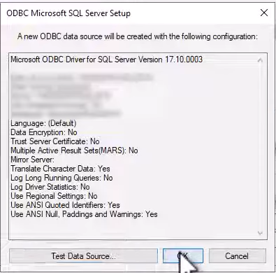
Click OK

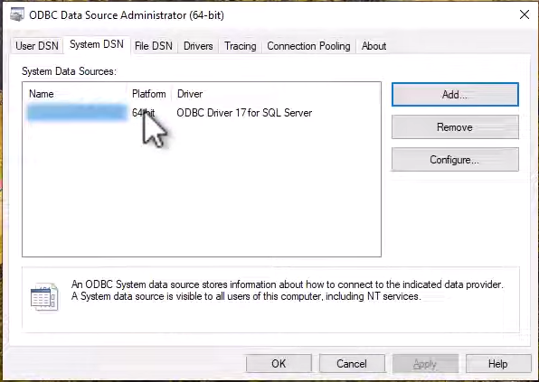
Click OK

Run Instruction

- **Change directory**
cd NRT_Monitor

- **Create a virtual environment**
py -m venv venv
.\venv\Scripts\activate # On Linux Mac OS: source venv/bin/activate
- If errors occurred, run this:
Set-ExecutionPolicy -ExecutionPolicy RemoteSigned -Scope CurrentUser

- **Install dependencies**
pip install -r requirements.txt

- Credentials configuration
In the Agent.py
SQL_SERVER = r"(local)\SQLEXPRESS" # eg.,: “(local)\SQLEXPRESS” or “DESKTOP-TAICUPD\SQLEXPRESS”
DATABASE = "NRT-V2"
SITE_NAME = " eg.,: Penang Courtyard "
SITE_CODE = DATABASE
API_URL = "https://script.google.com/macros/s/AKfycbxIAwFbkot1Q5X54EbhLik3NLq85KcpYVkeOyh-9Rjgui0nrcI5zIvQaVckHQWAxZju/exec"
API_KEY = "nrt_8F2xQ9mL7vP3zK1cR6wT4yH0bN5sJ8"
DASHBOARD_API_URL = "http://127.0.0.1:5000/api/nrt-status"

ALERT_THRESHOLD_HOURS = 48
COLLECTION_INTERVAL_MINUTES = 40

CONNECTION_STRING = (
"DRIVER={ODBC Driver 17 for SQL Server};"
f"SERVER={SQL_SERVER};"
f"DATABASE={DATABASE};"
"UID=sa;"
"PWD=qwerty7890;"
"Trusted_Connection=yes;"
)

- **Run the app**
Place both program one in the Central Server, another in the client site
On the Central Server, run:
python app.py

On the client side, run:
python agent.py

Output:
